Thursday

8:00-9:00- New Counselor Training- Ben
 | Anchorpoint | Legacy | Zeeland
9:00-9:15 | Devotions/Welcome | Devotions/Welcome | Devotions/Welcome
9:15-10:00 | Anchorpoint: Team Building (Room 120) | Legacy: Team Building (Art Room) | Zeeland: Awesome Time W/ Ben (Ben’s Room)
10:00-10:45 | Anchorpoint: “Kids Rock Teams” (Room 120) | Legacy: Awesome Time With Ben (Ben’s Room) | Zeeland: Team Building (Art Room)
10:45-11:30 | Anchorpoint: Awesome Time W/ Ben  (Ben’s Room) | Legacy: “Kids Rock Teams” (Room 120) | Zeeland: “Kids Rock Teams” (Art Room)
11:30-12:15 | Ed Camp | Ed Camp | Ed Camp
12:15-1:00 | Lunch | Lunch | Lunch
1:00-1:30 | Elective Draft | Elective Draft | Elective Draft
1:30-3 | Behavior Management- Jeff Ashby (Art room) | Behavior Management- Jeff Ashby (Art room) | Awesome Time w/ Ben (Ben’s Room)
3-4:30 | Awesome Time w/ Ben (Ben’s Room) | Awesome Time w/ Ben (Ben’s Room) | Behavior Management- Jeff Ashby (Art room)
Friday
8:30: Training and Planning at Each Camp
11:00: Organize, purchase supplies, set-up camp!
Lunch on your own this day
Rooms need to be set-up, everything bought and organized, DVDs/ Projectors tested!
Saturday
Continue camp set-up if needed

Go around the room
- Name, school attending/attended
- Fondest Childhood memory
- What did you pick on your fro-yo, and why
Quick Devotion
“If your first concern is to look after yourself, you’ll never find yourself. But if you forget about yourself and look to me, you’ll find both yourself and me” (Matthew 10:39, The Message).
Whoever wants to become great among you must be your servant, and whoever wants to be first must be your slave—just as the Son of Man did not come to be served, but to serve, and to give his life a ransom for many. Matthew 20:26b-28
Washed his feet, broke bread, gave his life
Are you doing something because you want the credit? Or to be kind? Or to lead?
Quick Prayer
- Describe your role last year as a team leader
- Ask for someone to add
- What were the challenging parts?
- What advice do you have for new team leaders?
Lay Out lines of authority
Team Leaders make day to day decisions, schedules, keeping teams on task
Site Directors support team leaders, are next on the chain of command for parents, do whole camp communication w/ parents, etc. are the go to person when you need that extra opinion/level of support. Behavior Problems, managing general conflict, accountability for counselors
In Both Roles, Very strong relationships with staff is key.
Give Scenarios
When to contact Ben- Panic- Parents are furious at something, lost a kid, huge injury, kick a kid out,etc.

Pyramid of a dysfunctional team

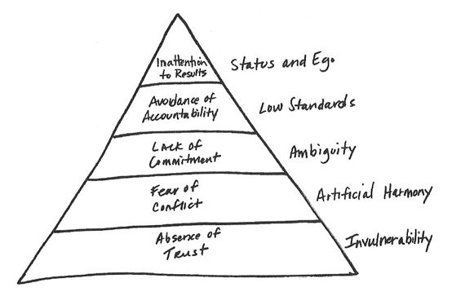

2. We will then split into 3 separate groups: Zeeland, Anchorpoint, and Legacy and so some brainstorming, so please come ready share your ideas, the topics we are brainstorming are: What things could be improved from last year? What things do you think we should cover at our training on the 15th?

3. We will then talk more specifically about what your roles will be at the training on the 15th and 16th... as you will be taking leadership in some things!

- If we have time... we may try to answer this question. If we had to pick one goal for the summer, that if we accomplished this one goal, we could say this summer was a huge success, what would it be?

